**Topic 6.6: Sum of Subarray Minimums**

**Question**  
Given an array of integers arr, find the sum of min(b), where b ranges over every contiguous subarray of arr. Since the answer may be large, return the answer modulo 10⁹ + 7.

**Aim**  
To calculate the sum of minimum values of all contiguous subarrays of the given array using an efficient algorithm.

**Algorithm**

1. For each element in the array, determine how many subarrays consider this element as the minimum.
2. Use **monotonic stacks** to compute:
   * The distance to the previous smaller element.
   * The distance to the next smaller element.
3. The contribution of each element is calculated as:
4. arr[i] * left[i] * right[i]

where left[i] is the number of subarrays ending at i in which arr[i] is the minimum, and right[i] is the number of subarrays starting at i in which arr[i] is the minimum.

1. Sum all contributions and take modulo 10⁹ + 7.

**Output**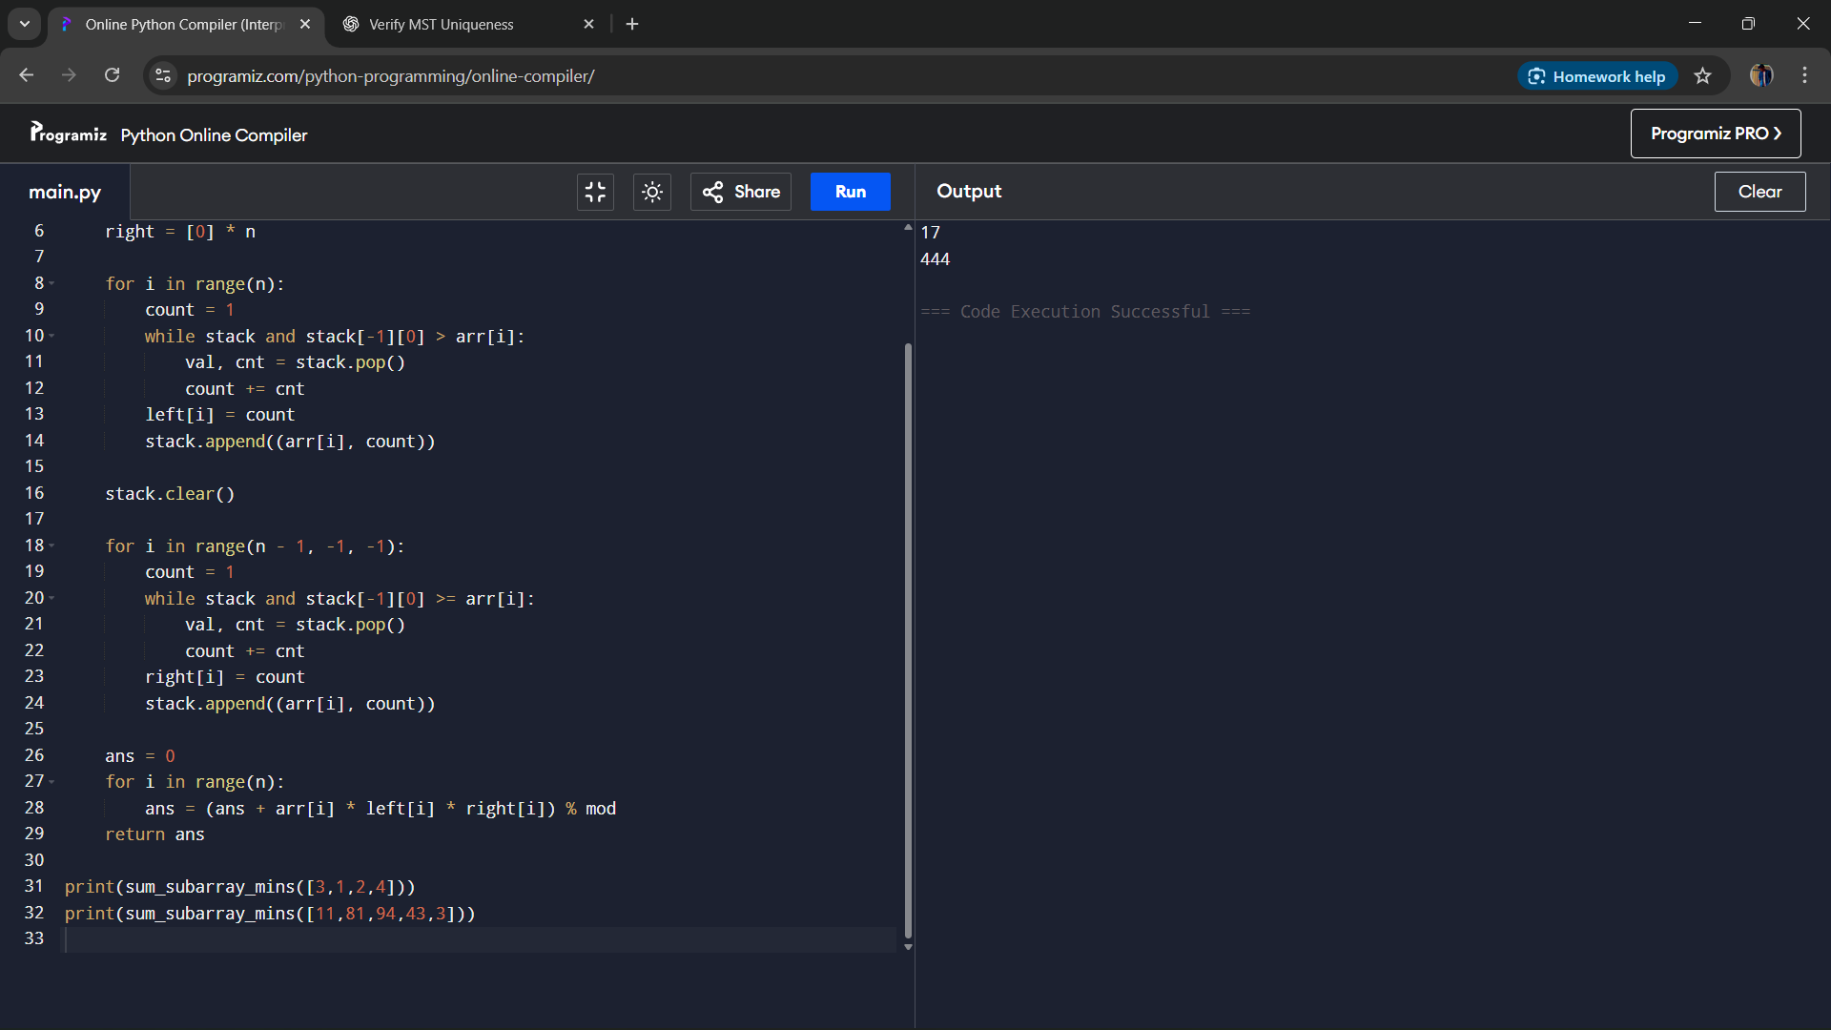

**Result**  
The program computes the sum of subarray minimums efficiently using monotonic stack logic.

**Performance Analysis**

* Time Complexity: O(n), as each element is pushed and popped from the stack once.
* Space Complexity: O(n) for storing stack and contribution arrays.